CS2212 Team 8 Meeting Minutes

**Date:** Feb. 24th, 2015

**Attendance:** Motahera Shermin (TA), Jaisen Bynoe, Geoffrey Leung, Chao Li (Lily), Hanxiang Pan (Henry), Anthony Taylor, Zihao Wang (Hans)

**Discussion:**

* JPanel layout
* Background image selection
* Interaction between each JPanel and integration with JFrame
  + 8 pages in total
* 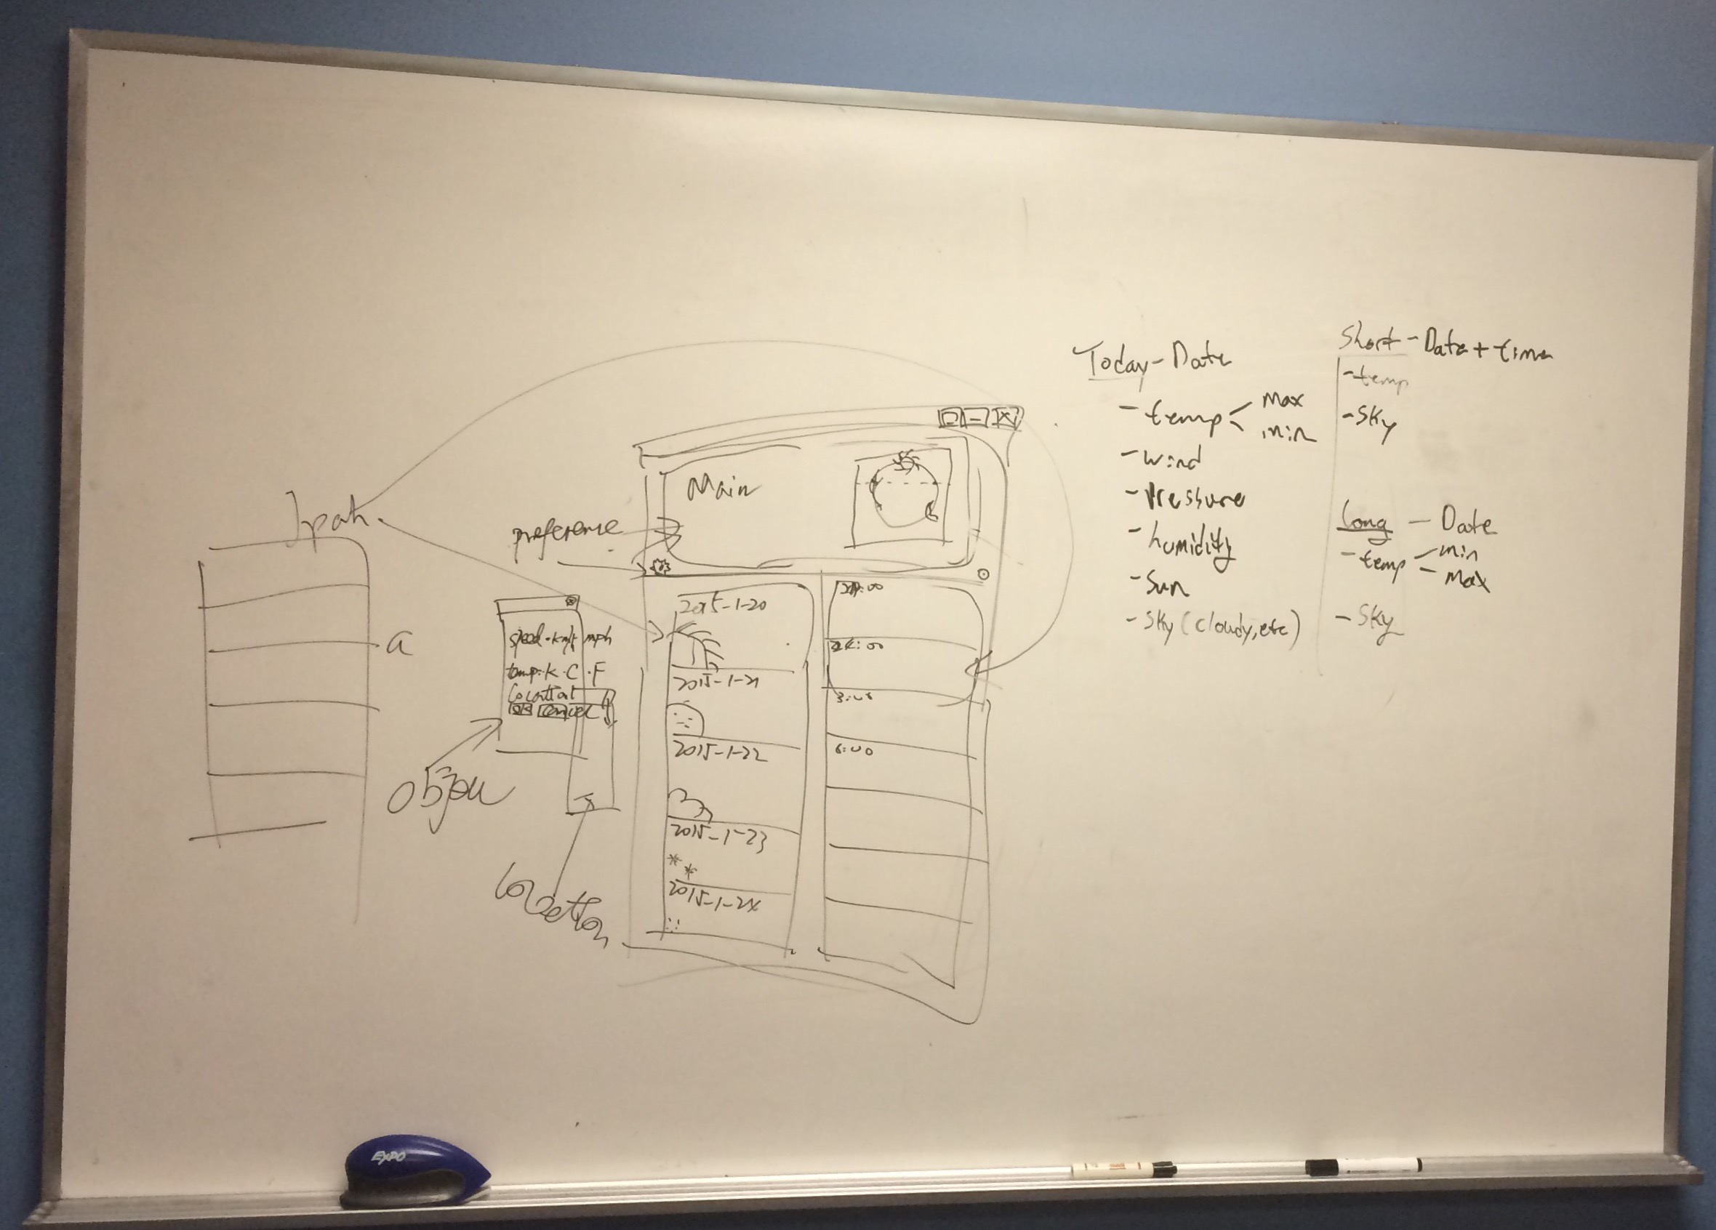Pivotal tracker revisions

**Things to be done before next week:**

* JPanel: Long, short, today – Jaisen, Geoffrey, Anthony
* Persistent of information – Hans, Lily
* Icon – Henry (use bit icons)
* Updating the wiki - Everyone